Operating and maintaining septic tank systems
This page gives an overview of rules for operation and maintenance of septic tank systems.
If you are installing a new system, it will also need to meet the requirement for new builds under the Code of Practice and other standards.
Overview
What can and can’t go in my septic tank?
How often does my septic tank have to be emptied (de-sludged)?
Who can empty a septic tank system?

Overview
Septic tanks and other domestic waste water treatment systems must:
- be registered with Protect Our Water;
- not be a risk to human health or the environment;
- not release waste water other than as designed or intended;
- be maintained;
- be emptied periodically; and
- roof water or surface water from yards must not enter the septic tank system.
These requirements are in the Water Services Act, 2007 (as amended) and in the Domestic Waste Water Treatment Systems Regulations, 2012.
Mechanical plants should be serviced by a professional every 12 months or as per the manufacturer’s instructions.
A professional should be engaged for any significant maintenance or if there are significant problems with septic tank systems.

What can and can’t go in my septic tank?
Domestic waste water is made up of sewage from toilets and ‘grey water’ from baths, showers, sinks, washing machines and dishwashers.

The 3 Ps | √ | Only pee, poo and paper should go in the toilet; do not put cotton buds, wipes, etc. in the toilet as they cause blockages.
Grey water | √ | Grey water (see above) can contain chemicals, grease and other pollutants and should go to the septic tank system. It should not go to the roof and yard water drains.
Food waste, fats, oils and greases | ? | Excessive amounts of food waste, fats, oils and greases can cause blockages, smells and impair your treatment system. There is guidance available on My Waste on how to recycle or dispose of these wastes.
Bleach or disinfectants | ? | Normal amounts of household bleach, disinfectants and detergents will not harm a septic tank system. Excessive amounts may temporarily reduce the treatment capacity, as the microorganisms needed to treat the biological waste will be killed off. However, the system should return to full performance capacity within a short period of time.
Roof and yard water | X | Roof and yard water should not go to the septic tank system as it may overload it. It should be collected separately and discharged to its own soakaway or to a watercourse.
Unused medicines | X | Antimicrobial resistance occurs when microbes, such as bacteria, become resistant to the drugs used to treat them. This is already a serious problem and is increasing. Please do your part by disposing of unused medicines appropriately. There is guidance available on My Waste on how to dispose of these wastes.

How often does my septic tank have to be emptied (de-sludged)?
Septic tanks and other domestic waste water treatment systems need to be emptied periodically to remove sludge. This is a legal and practical requirement. If the sludge builds up too much, it may affect treatment and block the system requiring expensive repair or replacement works. The law requires home owners to keep a receipt of de-sludging for five years.
The following table can be used to find out how often you need to empty your septic tank system. This depends on the number of occupants in the home and the tank size. Assume the tank is 2.5m3 if you do not know its size.

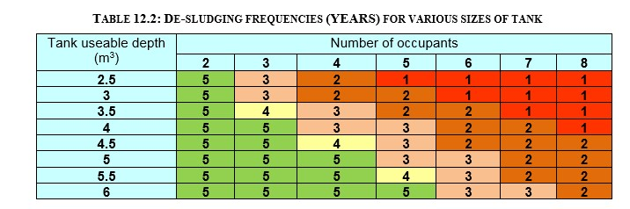
Example: A 3.5m3 tank for a 3-person house needs de-sludging every 4 years.

Mechanical plants should be emptied as recommended by the manufacturer

Who can empty a septic tank system?
You must use an authorised waste collector only. You can check online with the National Waste Collection Permit Office.

Farmers can de-sludge their own system only. They must comply with all legal rules or directions including:

- Waste Management (Use of Sewage Sludge in Agriculture) Regulations 1998;
- Waste Management (Use of Sewage Sludge in Agriculture) (Amendment) Regulations 2001; and
- European Communities (Good Agricultural Practice for Protection of Waters) Regulations 2010.
Farmers can find out about spreading sludge from their own system in this leaflet.

